- -- Retrieve the total number of orders placed
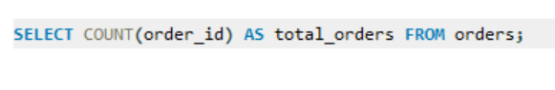
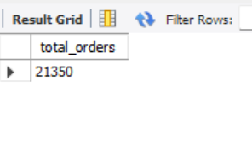

- -- Calculate the total revenue generate from pizza sales

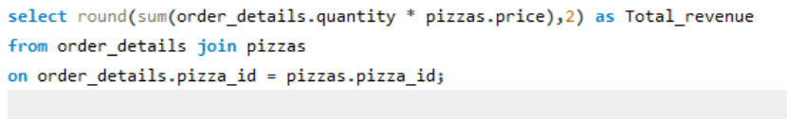

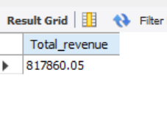

- -- Identify the highest priced pizza
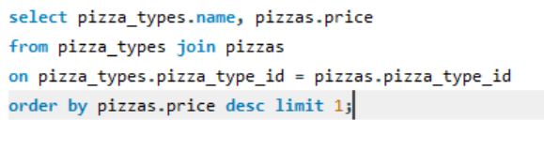
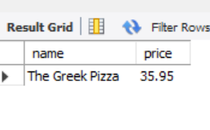
- -- Identify the most common pizza size ordered

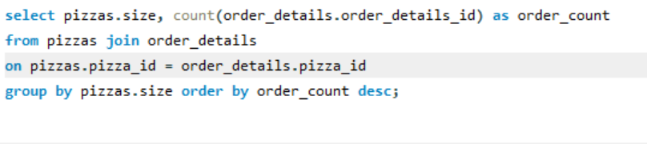

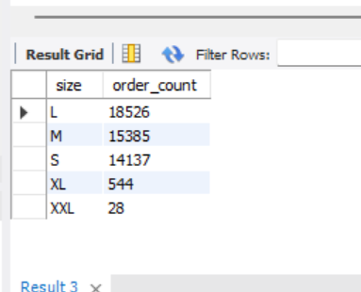

- -- List the top 5 most ordered pizza types along with their quantity’s
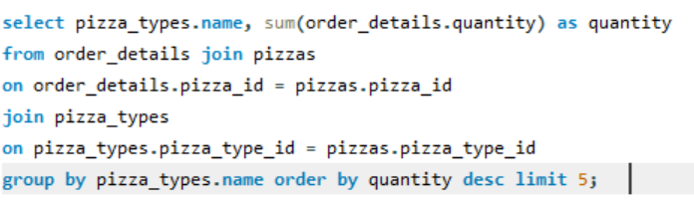
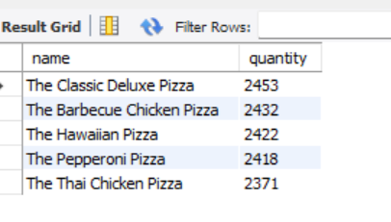

- Join the necessary tables to find the total quantity of each pizza category ordered

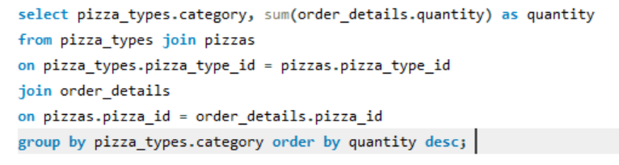
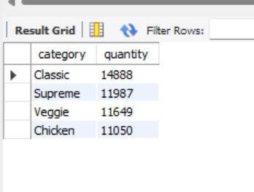

- -- Determine the distribution of orders by hour of the day
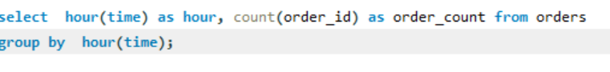
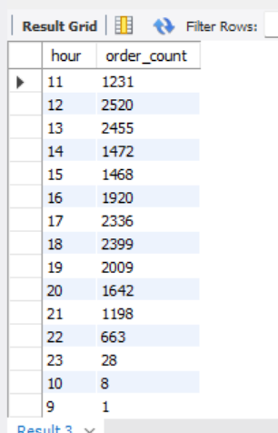

- -- Join relevant tables to find the category wise distribution of pizzas
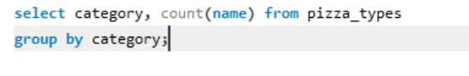
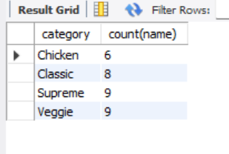

- -- Group the orders by date and average number of pizzas ordered per day
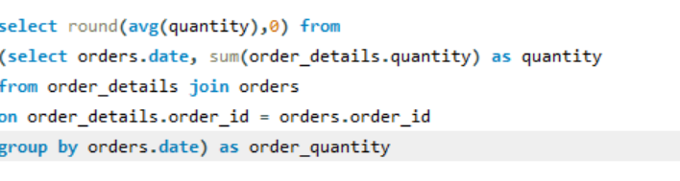
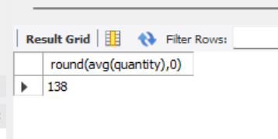

- -- Determine the top 3 most ordered pizza types based on revenue
